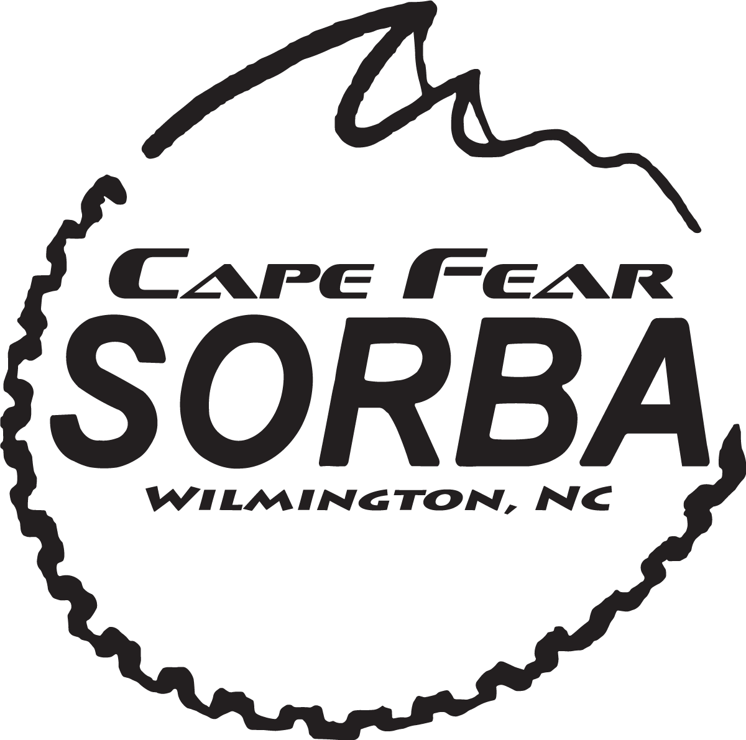
Jersey Order Form
Please fill out the entire form and deliver to Two Wheeler Dealer at 4408 Wrightsville Ave, Wilmington NC 28403. Please deliver with payment. Payment will be accepted in the form of check (made out to Cape Fear SORBA) or cash. If you have any questions please email info@capefearsorba.com. Delivery will take about 8 weeks from date we place the entire order with Canari. Jersey orders will be available for pickup at Two Wheeler Dealer. You will be notified via email when the shipment arrives.

Jersey price is $58

Name: ___________________________________

Address: _________________________________

_________________________________

City: ____________________________________

State: ____________________________________

Phone Number: ____________________________

Email: ___________________________________

PLEASE CIRCLE YOUR JERSEY SIZE
(If ordering more than 1 please indicate below in empty space)

X-SMALL SMALL MEDIUM LARGE X-LARGE XX-LARGE

